PERFORMA FOR WORK CONTRACT
(On the company letterhead in duplicate to be signed by the client and the architect )

To
.Mr.

JKS. ARCHITECTS
57/58 ,SECTOR – 8, CHITRAKOOT, VAISHALI NAGAR, JAIPUR

SUB: Assignment for Interior and related Professional Services.

Project:
Interior Design

Dear Sir,
We hereby providing the details of Interior and related professional services as detailed out in our offer letter for the project mentioned above.
This work contract document includes the following annexe attached herewith:

- Annexure I - Scope of work under the contract.
- Annexure II - Total Consultancy and mode of payment.

WHY CHOOSE JKS ARCHITECTS

PROJECT MANAGEMENT TRIANGLE
Following are the benefits of choosing Jks Architects for developing this application
– “You can have it good, fast, or cheap. Pick two.”
We at jks Architects maintain the perfect balance between all the sides of the project management triangle to ensure we deliver a high quality end product.
Jks Architects
In slightly different terms, every project needs to balance a “triangle” of time, cost, and scope. We can’t change one without affecting at least one of the others. Referring to the diagram to the above, the Triple Constraint basically demonstrates in pictorial fashion, the key attributes that must be handled effectively for successful completion and closure of any project.
The project management triangle is used by our managers to analyze or understand the difficulties that may arise due to implementing and executing a project.
This document should not be judge as a final proposal. After our conversation we will share the final proposal with you.

ANNEXURE – I

SCOPE OF WORK :

The Composite Consultancy comprises of items tick-marked in boxes:

A. INTERIOR CONSULTANCY:

- STAGE: (Invoice Stages 1)
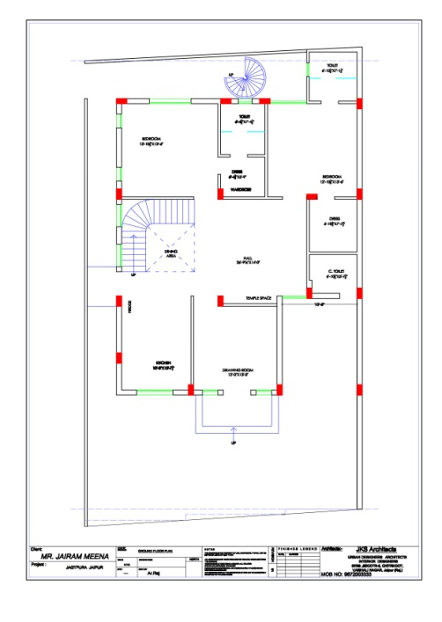

PLAN
House Enters Drawing Area Island Kitchen
Store Temple Space
Hall
M.Bedroom
Dressing Room
Kids Room
Parking
Garden

- FURNITURE LAYOUT
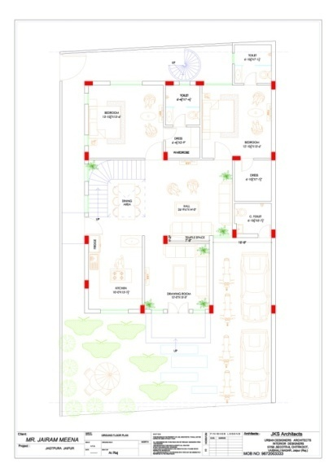
Car Define
Sofa set
L.C.D.
Kitchen hop Kitchen Sing Wash Basin Dining Table
Toilet- W.c.,Shower
Crockery unit
King Size Bed
Side Table
Wardrobe

NOTE: Above Underlined Stages Should Be Selected By The Client.

- STAGE (Invoice Stages 2)
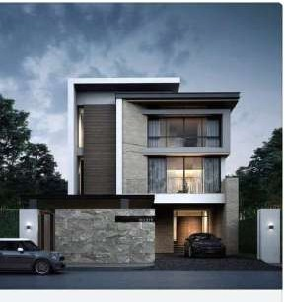

INTERIOR 3D ELEVATION
Type Elevation
No. Of Floor
Stone detail
Glass & Steel Reling

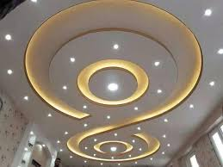
FALSE CEILING 3D ELEVATION

- INTERIOR WORKING PLAN
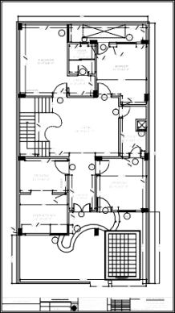

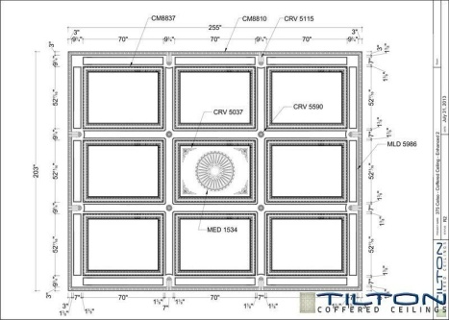
- FALSE CEILING WORKING PLAN

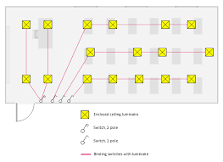
FALSE CEILING ELECTRICAL PLAN

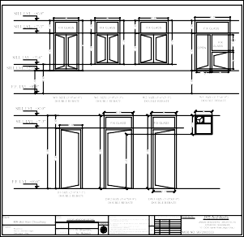
- DOOR /WINDOW SHEDULE
- Door lintel Level
- Windows SIL Level
- Windows Lintel Level

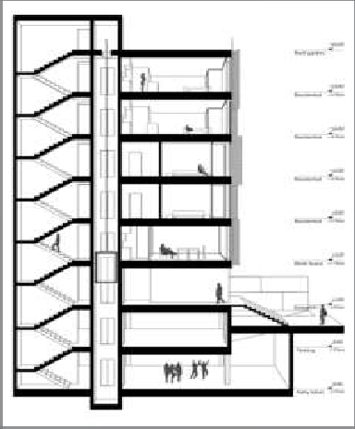
- SECTIONAL DETAIL

Both site Section Details
Level definition
D.P.C. To Wall Height
Beam Size Details
Lintel Level

NOTE: Above Underlined Stages Should Be Selected By The Client.

- STAGE (Invoice Stages 3)

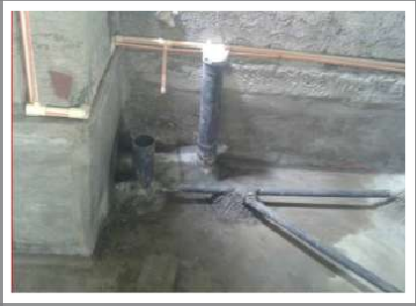
SANITARY FLOOR PLAN
C.P.V.C. Pipe where outer site come
Chamber details
Soil west Water Chamber
West waters Chamber
Chamber Peking

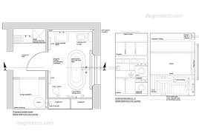
- SANITARY WORKING PLAN

- 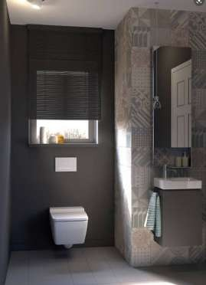WALL SANITARY PLAN
C.P.V.C. Pipe Size plan
According to size of pipe projection location
Height of pipe According to Cubicle
Chamber testing
Water Flows then Feeting

- ROOF C.C.T.V. CAMERA
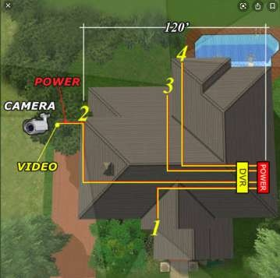Before Roof Casting CCTV Pipe Installation
Distribution Box Location
Type of camera

- 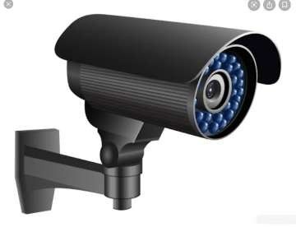WALL C.C.T.V. CAMERA
DistributionBox Instolesan
Camera Wall height Details
Wiring Details

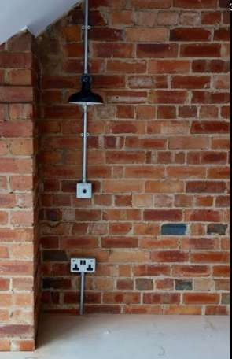

WALL ELECTRICAL
Type of Switch Box Details
Main powers points
Wall light points show
Wiring details

- 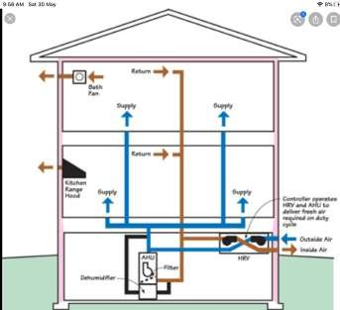AIR CONDITIONING
Copper pipe Feeting
West water pipe Feeting
Electric wire for 4 mm Required

NOTE: Above Underlined Stages Should Be Selected By The Client.

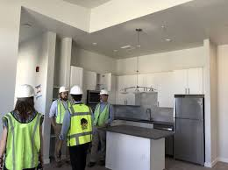

SITE VISIT
  - 3D Interior
  - 3D Working
  - False Ceiling
4 . Electrical Wall
5. Sanitary Wall & Floor

NOTE: ABOVE MENTIONED SITE VISITS ARE FREE OF COST.
EXTRA SITE VISITS ARE CHARGEABLE . IN JAIPUR 2000`/VISIT AND OUT OF JAIPUR 10000`/VISIT (ACCORDING TO LOCATION)

ANNEXURE - II

A: COMPUTATION OF CONSULTANCY FEES FOR THE ABOVE SERVICES:
Total Consultancy = Total Built up Area-------x @ Rs.----/ sqft. =RS -----------
PLS. NOTE: Service tax will be charged on the above amount (@18%).

MODE OF Work

S. No. | Stage of Work | Stage Payments | Total Amount to be paid till this stage
1 | Layout Plan | 20/sq.fit | 20 ` /sq.fit of total Area.
2 | 3D plan | 20/sq.fit | 40 ` /sq.fit of total Area
3 | Elevation, Working Plan | 10/sq.fit | 50 ` /sq.fit of total Area

MODE OF PAYMENT

S. No. | Stage of Payments | Stage Payments | Total Amount to be paid till this stage
1 | Before Layout Plan | 20 | 20 ` /sq.fit of total Area.
2 | Before 3D Plan | 20 | 40 ` /sq.fit of total Area
3 | Before Elevation , Working Plan | 10 | 50 ` /sq.fit of total Area

Date:

DECLARATION OF ACCEPTANCE OF WORK

I, here by accept the above said conditions for appointment of Architect for my project stated above.

Proprietor
JKS. ARCHITECTS
57/58 ,SECTOR – 8, CHITRAKOOT,

VAISHALI NAGAR, JAIPUR
Email: jksarchitects92@gmail.com
M.NO: 8955621119
9672003333 FOR CUSTOMER

